1.Class Diagram

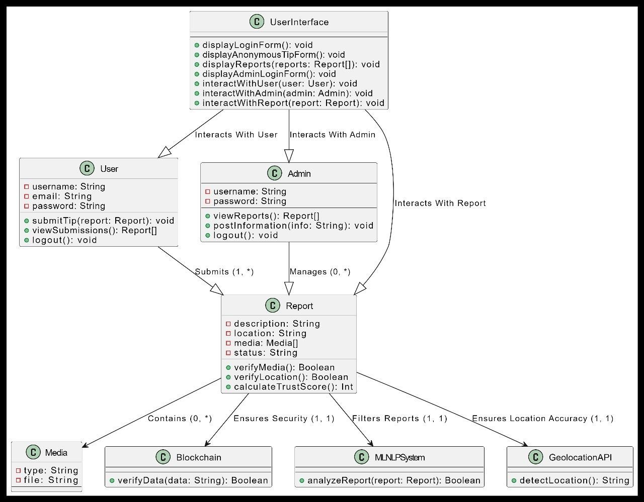

2.Use Case Diagram Code

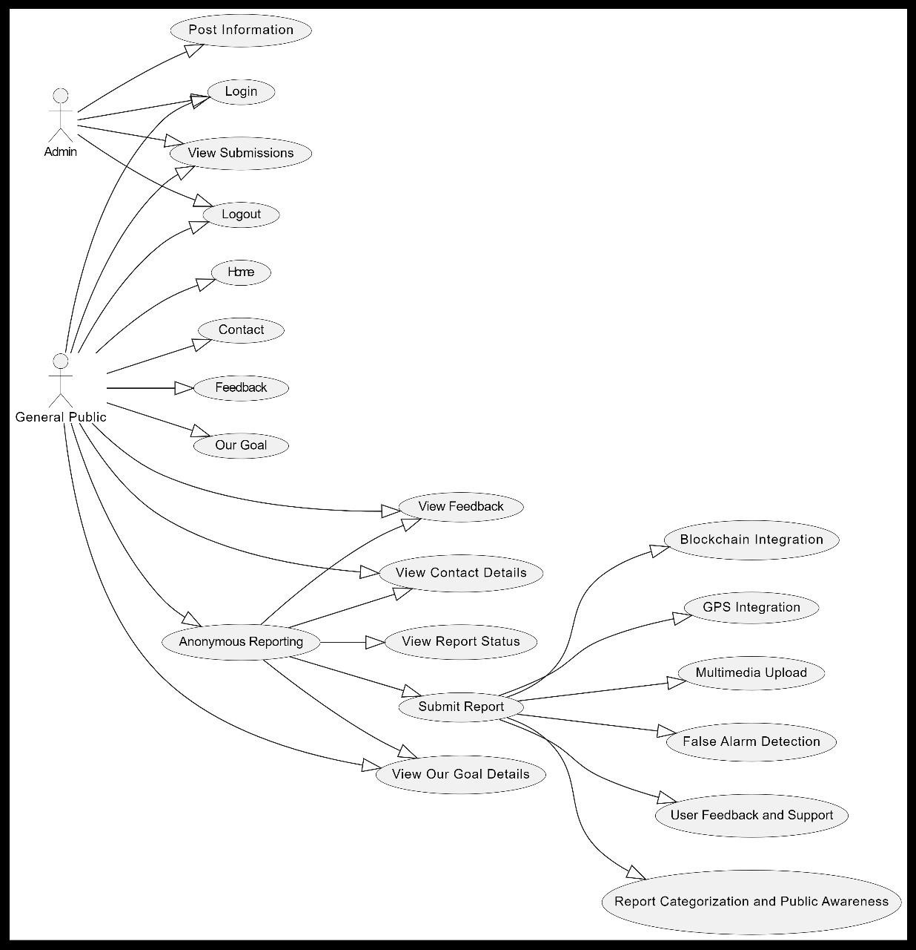

3.Deployment Diagram

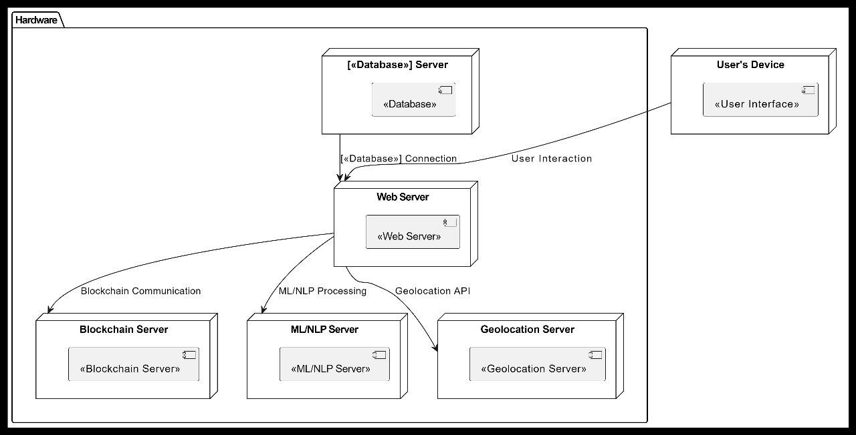

4.Object Diagram

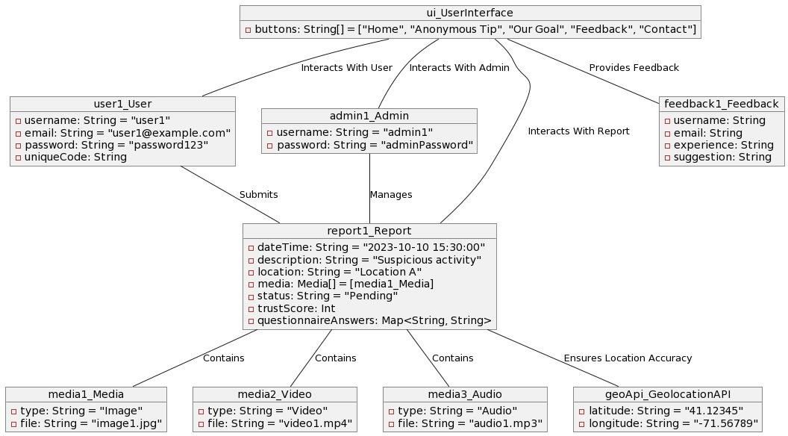

5.Sequence Diagram

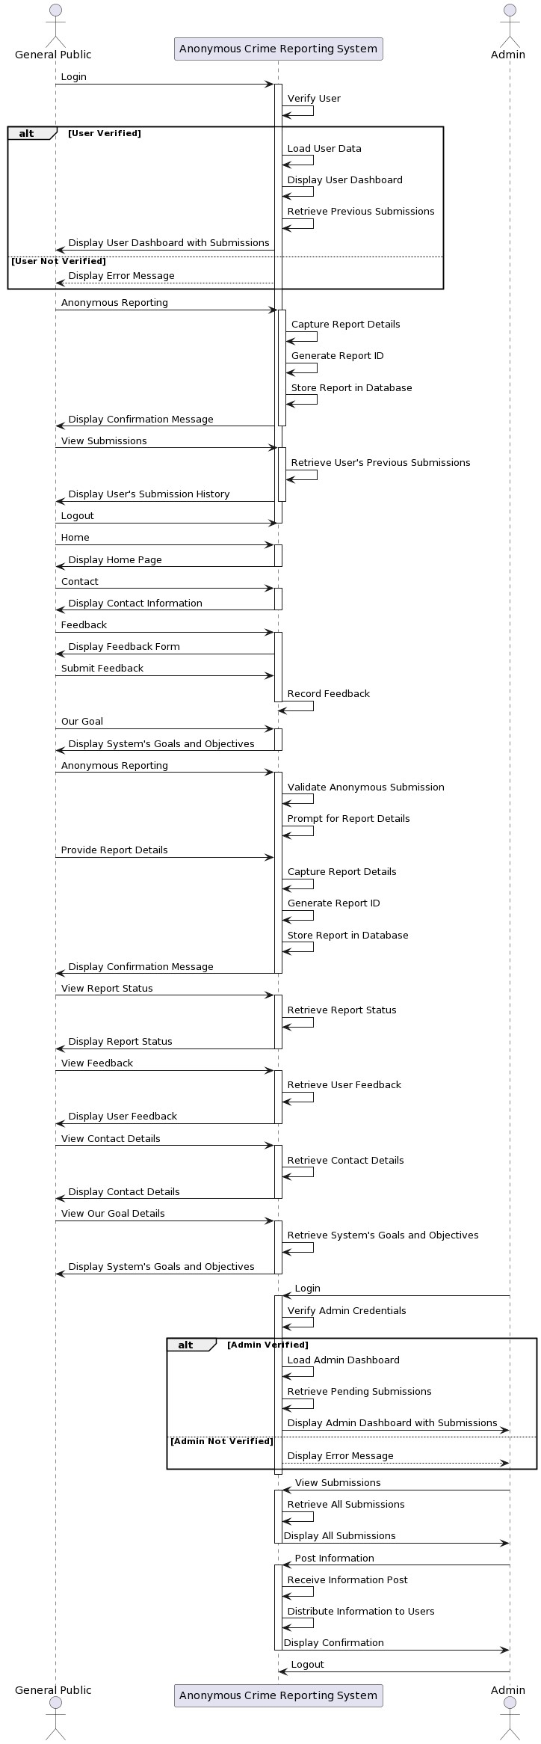

6.Component Diagram

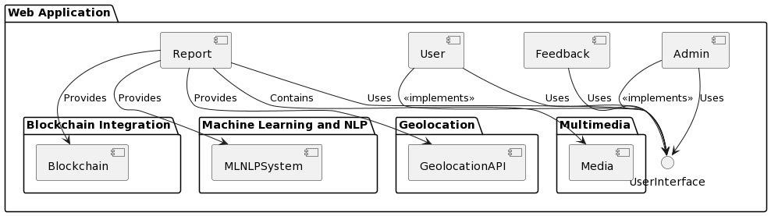

7.StateChart Diagram

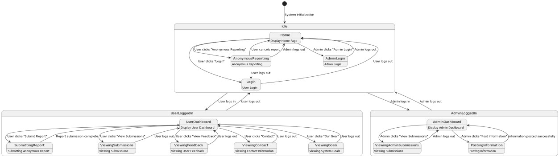

8.Activity Diagram

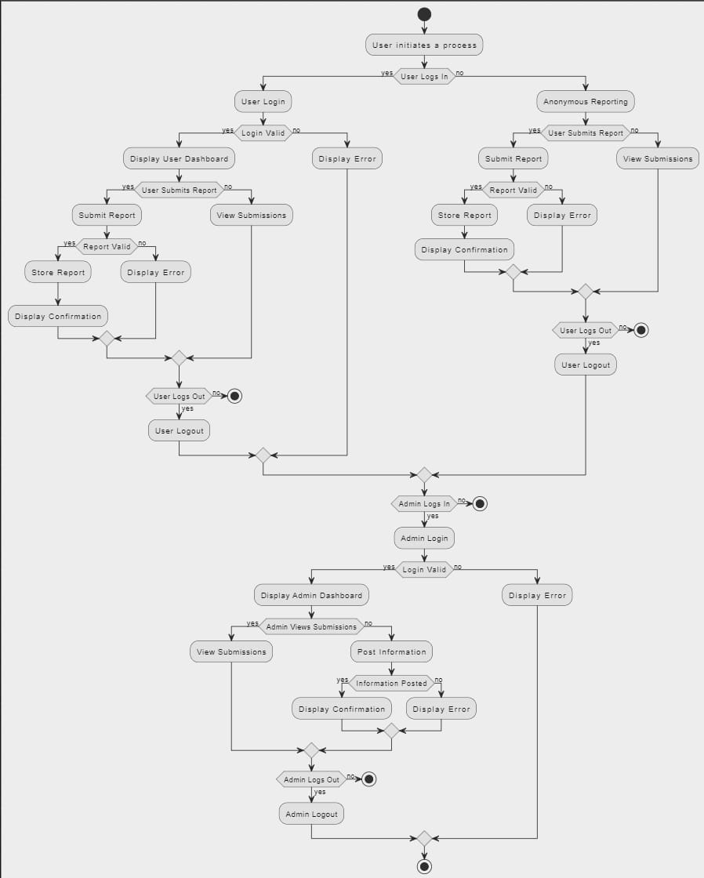

9.Collaboration Diagram

